Request for Initial Gateway Determination

**Relevant Planning Authority Details**

**Name of Relevant Planning Authority: Walgett Shire Council**

**Contact Person: Matt Clarkson**

**Contact Phone Number and Email Address: (02) 6828 1399, mclarkson@walgett.nsw.gov.au**

**Planning Proposal Details - Attachments**

1. **LAND INVOLVED:**

* Lot 15 DP 750313 (Namoi St Walgett).
* Lot 7010 DP 1021112 (Pitt St Walgett).
* Lot 16 DP 750313 (Namoi St Walgett).
* Lot 89 DP 997415 (115 Wee Waa St Walgett).
* Lots 1 & 2 DP 1190485, Lot 36 DP 231207 (20, 22 & 24 Keepit St Walgett).
* Lot 342 DP 875558 (19 Montkeila St Walgett).
* Lots 2-9 DP 846336 (104, 108, 112, 116, 120, 124, 128 & 130 Pandora St Lightning Ridge).
* Lots 1-20 Section 18 DP 759036 (Euroka St & Wee Waa St Walgett).
* Lot 100 DP 1162159, Lots 63, 64, 65 DP 46643 (Collarenebri).
* Lot 3 Section 4 DP 758262 (18 Wilson St Collarenebri).
* Lot 22 DP 579731(3 Warrena St Walgett).
* Lot 77 DP 820441, Lot 3 DP 1158025, Lot 128 DP 1118679, Lot 1 DP 1062072, Lot 2 DP 1062072, Lots 50-71& 75-76 DP 838673, Lot 3 DP 1158025, Lot 177 DP 1073508, Lot 77 DP 820441, and Lot 511 DP 1201786 (Lightning Ridge).
* Lot 2 DP 1106775 (Collarenebri).

**Attached/Completed ✓**

**2. MAPS (If applicable – 1 electronic and 2 hard copy)** 🞎

* Location map showing the land affected by the proposed draft plan in the context of the LGA (tagged 'location map').
* Existing zoning map showing the existing zoning of the site and surrounding land and proposed zoning change for the site/s (tagged 'comparative existing/proposed zoning')

**3. PHOTOS and other visual material (if applicable)** 🞎

* Aerial photos of land affected by the Planning Proposal
* Photos of land involved and surrounding land uses

**4. COMPLETE PLANNING PROPOSAL (1 electronic and 2 hard copy)** 🞎

* All matters to be addressed in a planning proposal – including Director-General’s requirements for the justification of all planning proposals (other than those that solely reclassify public land) in accordance with a 'Guide to preparing a planning proposal ' are completed prior to forwarding to the Regional Office in the first instance. See attached pro-forma.

**4. PLANNING PROPOSAL HAS BEEN SUPPORTED BY COUNCIL** 🞎

* Council has considered the written planning proposal before it is sent to the Department of Planning.
* Attached is Council’s resolution to send the written planning proposal to the Department of Planning.

………………………………………………………………………………………………………………………

Signed for and on behalf of the Relevant Planning Authority DATE: *DD/MM/YY*

Planning Proposal for flood clause amendment, heritage recognition and rezoning in Walgett Shire

**Part 1 - Objectives or Intended Outcomes**

Objective 1: Rationalise zone boundaries to accommodate future development and omissions in the preparation of the Walgett Local Environmental Plan 2013 (LEP).

Objective 2: Amend wording of Clause 6.2 Flood Planning of the LEP to reflect lack of flood planning level data to provide a 1:100 average recurrent interval flood event.

Objective 3: Include newly identified items of Environmental Heritage and remove items that are no longer viable.

Objective 4: Enable installation of manufactured homes on properties outside the urban footprint.

Objective 5: Enable construction of a new tourist attraction on the Lightning Ridge preserved opal fields.

Presently the provisions of the LEP do not reflect some existing or desired uses within the Walgett and Lightning Ridge urban footprints.

It is the objective of the Council to provide:

* Sufficient land stock in appropriate zones to facilitate development.
* A flood planning clause which reflects development standards applied to flood liable areas in the absence of a flood study.
* Recognition in the LEP of relevant items with local heritage significance.
* An extension to the airport of 100 metres.
* Make manufactured homes permissible with consent in the RU1 Primary Production zone, R5 Large Lot Residential zone, and E4 Environmental Living zone.
* An Additional Permitted Use – Information and Education facility (observatory) for Lot 177 DP 1073508 in the SP1 Special Activities zone.

Intended outcomes include:

* Public exhibition of proposed amendments to obtain community and government feedback.
* Amendment of Clause 6.2 Flood Planning of the LEP.
* Amendment of the Walgett Local Environmental Plan 2013 Land Zoning Maps (ref: LZN_004AA, LZN_004A, LZN_004AB & LZN_005AA).
* Amendment of the Walgett Local Environmental Plan 2013 Lot Size Maps (ref: LSZ_004AA, LSZ_004A, LSZ_004AB & LSZ_005AA).
* Amendment of the Walgett Local Environmental Plan 2013 Heritage Maps (ref: HER_005, HER_005AA, HER_005B & HER_008).
* Amendment of the Land Use Table of the LEP.
* Amendment of the Walgett Local Environmental Plan 2013 Additional Permitted Uses Maps (ref: APU_004A).

**Part 2 - Explanation of Provisions**

The intended outcomes of the planning proposal will be achieved by:

1. Amendment of Clause 6.2 Flood Planning of the Walgett LEP 2013 to remove references to a flood planning level and average recurrent interval flood events (as per Cobar LEP).
2. Amending the Walgett LEP 2013 to rezone Lot 15 DP 750313 from RE1 Public Recreation to SP2 Infrastructure to allow for construction of the new Walgett Council depot (prohibited in RE1 zone).
3. Amending the Walgett LEP 2013 to rezone Lot 7010 DP 1021112 and Lot 16 DP 750313 from R1 General Residential to SP2 Infrastructure to allow for construction of the new Walgett Council depot (prohibited in R1 zone).
4. Amending the Walgett LEP 2013 to rezone Lot 89 DP 997415 from R1 General Residential to IN1 General Industrial to reflect anticipated future demand to develop the lot with an industrial use now that it no longer contains a dwelling.
5. Amending the Walgett LEP 2013 to rezone Lots 1 & 2 DP 1190485, Lot 36 DP 231207 and Lot 342 DP 875558 from R1 General Residential to B2 Local Centre to reflect current commercial use.
6. Amending the Walgett LEP 2013 to rezone Lots 2-9 DP 846336 from SP3 Tourist to R1 General Residential to provide for new residential development.
7. Amending the Walgett LEP 2013 to rezone Lots 1-20 Section 18 DP 759036 from R1 General Residential to SP2 Infrastructure to reflect current use as Water Supply System and stormwater detention pond.
8. Amending the Walgett LEP 2013 to make minor boundary adjustments to the Lightning ridge SP1 Special Activities zone to align with cadastral boundaries.
9. Amending the Walgett LEP 2013 Schedule 5 Environmental Heritage to include:

* The Collarenebri Aboriginal Cemetery (Lot 100 DP 1162159, Lots 63, 64, 65 DP 46643).
* The Collarenebri Racecourse Grandstand (Lot 2 DP 1106775).

1. Amending the Walgett LEP 2013 Schedule 5 Environmental Heritage to remove:

* The Collarenebri Old Bakery Complex (Item I 25, Lot 3 Section 4 DP 758262).

House in Walgett (Item I 80, Lot 22 DP 579731).

1. Amending the Walgett LEP 2013 to rezone part Lot 511 DP 1201786 from SP1 Special Activities to SP2 Infrastructure to provide for a 100 metre extension to the Lightning Ridge airport.
2. Amendment of the Walgett Local Environmental Plan 2013 Additional Permitted Uses Maps APU_004A to make an Information and Education facility (observatory) permissible with consent on Lot 177 DP 1073508.
3. Amending the Walgett LEP 2013 Land Use Table to make residential accommodation permissible with consent in the RU1 Primary Production zone, R5 Large Lot Residential zone, and E4 Environmental Living zone. Amending the Walgett LEP 2013 Land Use Table to make hostels, multi-dwelling housing, group homes, seniors housing, shop top housing, residential flat buildings, and boarding houses prohibited in the RU1 Primary Production zone, R5 Large Lot Residential zone, and E4 Environmental Living zone.

**Part 3 - Justification**

**Section A - Need for the planning proposal**

**Q1.** Is the planning proposal a result of any strategic study or report?

Yes The general rationale behind the rezoning component proposal is supported by the Walgett Shire Growth Management Study and Strategy (2010). The strategy notes that:

* The current location of the Council depot is incompatible with surrounding dominant land uses, and recommends relocation, albeit in a different location to that proposed here.
* Relocation of the depot will free up circa 4.6 hectares of land, or up to 60 lots at 700m2.
* There is significant demand for residential land in Lightning Ridge, in the context where there is minimal undeveloped residential land stock available for sale (No lots at the time of writing).

Justification of Proposed LEP Amendments

1. *Amendment of Clause 6.2 Flood Planning of the Walgett LEP 2013* – It is appropriate to remove references to a flood planning level and average recurrent interval flood events as no flood study for Walgett Shire has been done.
2. *Amending the Walgett LEP 2013 to rezone Lot 15 DP 750313 from RE1 Public Recreation to SP2 Infrastructure – Map A*. Provision was made in the Walgett LEP 2013 for a new Council depot, however no provision was made for access (Lot 15). Rezoning of this lot will address this omission.
3. *Amending the Walgett LEP 2013 to rezone Lot 7010 DP 1021112 and Lot 16 DP 750313 from R1 General Residential to SP2 Infrastructure to allow for construction of the new Walgett Council depot - Map B*. Provision was made in the Walgett LEP 2013 for a new Council depot, however no provision was made for staff parking (Lot 7010) and access (Lot 16). Rezoning of these two lots will address this omission. Council has investigated, and is of the understanding that there is no community land within the shire (believed to be extinguished by the Walgett Local Environmental Plan 2006—Classification and Reclassification of Public Land).
4. *Amending the Walgett LEP 2013 to rezone Lot 89 DP 997415 from R1 General Residential to IN1 General Industrial – Map C*. This lot was not zoned industrial in line with surrounding zoning at the time of preparation of the LEP as it contained a house. The house has since burned down, and the neighbouring freight business which owns the lot would like to be able to expand their operations over the site. A letter from the owner in support of the rezoning forms Attachment D.
5. *Amending the Walgett LEP 2013 to rezone Lots 1 & 2 DP 1190485, Lot 36 DP 231207 and Lot 342 DP 875558 from R1 General Residential to B2 Local Centre – Map D*. These lots have been used for business purposes for many years, and their zoning as residential was an error made in the preparation of the LEP. Amending the zoning to B2 Local Centre is appropriate to reflect their current and historical use. A letter from the owner of Lot 1 DP 1190485, Lot 36 DP 231207 and Lot 342 DP 875558 in support of the rezoning forms Attachment E.
6. *Rezoning Lots 2-9 DP 846336 from SP3 Tourist to R1 General Residential in Lightning Ridge - Map E*. Since preparation of the Walgett Shire Growth Management Study and Strategy in 2010, the then available residential land stock in Lightning Ridge has been developed, and Crown Lands has advised that it is unlikely to enter into a private treaty with Council to release land for residential subdivision. As there is an abundance of SP3 Tourist zone land available for development, and none available for new housing, it is proposed to rezone a small amount of the SP3 Tourist zone to provide for current demand.
7. *Amending the Walgett LEP 2013 to rezone Lots 1-20 Section 18 DP 759036 from R1 General Residential to SP2 Infrastructure to reflect current use as Water Supply System and stormwater detention pond – Map F*. Since preparation of the Walgett Shire Growth Management Study and Strategy in 2010, a Water Supply System has been constructed over Lots 1-9 & 20. Lots 10-19 contain a large stormwater detention pond which makes them unsuitable for residential development. Rezoning is appropriate to reflect their current use.
8. *Amending the Walgett LEP 2013 Schedule 5 Environmental Heritage to include the Collarenebri Aboriginal Cemetery (Lot 100 DP 1162159, Lots 63, 64, 65 DP 46643) and the Collarenebri Racecourse Grandstand (Lot 2 DP 1106775) – Maps G & H*. The cemetery has state historical association, aesthetic and technical / research significance, rarity and representativeness. It also has local historical / social significance and a high degree of integrity. The grandstand has local historical, historical association, aesthetic / social significance, rarity, representativeness and a high degree of integrity.
9. *Amending the Walgett LEP 2013 Schedule 5 Environmental Heritage to remove the Collarenebri Old Bakery Complex (item I 25, Lot 3 Section 4 DP 758262) and House in Walgett (item I 80, Lot 22 DP 579731) – Maps K & I.* The Old Bakery Complex was damaged in a fire some years ago and is partly demolished. Council’s Heritage Advisor has advised that the bakery is unstable, represents a public hazard, and will not survive the next few years regardless of a heritage listing. The House in Walgett has been vacant for many years and the roofs have collapsed, rendering it uninhabitable. Council’s Heritage Advisor has advised that quotes obtained to stabilise the structure are well beyond the means of the current owners who have requested permission to demolish it so that an affordable structure can be built on site. He has further advised that demolition is the only practical solution for the site.
10. *Amending the Walgett LEP 2013 to make minor boundary adjustments to the Lightning ridge SP1 Special Activities zone – Maps K1 to K6.* It is appropriate to amend these maps as zone boundaries should align with cadastral boundaries where possible.
11. *Amending the Walgett LEP 2013 to rezone part Lot 511 DP 1201786 from SP1 Special Activities to SP2 Infrastructure – Map L*. Council has received a grant to extend the Lightning Ridge airport to accept larger planes, requiring rezoning of a small portion of the SP1 special activities zone.
12. *Amendment of the Walgett Local Environmental Plan 2013 Additional Permitted Uses Maps APU_004A to make an Information and Education facility (observatory) permissible with consent on Lot 177 DP 1073508 – Map M.* A small, publicly accessible observatory can reasonably be expected to compliment the partial transition of the Lightning Ridge economy from opal mining to tourism.
13. *Amending the Walgett LEP 2013 Land Use Table to make residential accommodation permissible with consent in the RU1 Primary Production zone, R5 Large Lot Residential zone, and E4 Environmental Living zone.* Manufactured homes do not meet the definition of a ‘dwelling house’ in the LEP dictionary, hence are prohibited in these zones. As manufactured homes are the dominant form of new housing within Walgett Shire, their prohibition in the RU1 Primary Production zone, R5 Large Lot Residential zone, and E4 Environmental Living zone presents as an unreasonable and impractical restriction. Addition of ‘residential accommodation’ to the Land Use Table for this zone would remove any such restriction. To prevent this modification enabling undesirable development, the Land Use Table for RU1 Primary Production zone, R5 Large Lot Residential zone, and E4 Environmental Living zone would also need to be modified to prohibit hostels, multi-dwelling housing, group homes, seniors housing, shop top housing, residential flat buildings, and boarding houses.

**Q2**. Is the planning proposal the best means of achieving the objectives or intended outcomes, or is there a better way?

Yes. It is considered that the Planning Proposal is the best means of achieving the objectives and intended outcomes.

Is there a net community benefit?

Yes.

1. Amendment of the flood clause will provide greater clarity to homeowners, developers and insurers regarding how flood risk is assessed in the Walgett Shire.
2. Rezoning Lots 2-9 DP 846336 from SP3 Tourist to R1 General Residential in Lightning Ridge will provide new residential lots in an area where insufficient residential land stock is available.
3. Relocation of the works depot in Walgett will provide in excess of 10 years residential land stock in a location where such land is lacking.
4. The extension to the Lightning Ridge airport is part of a suite of measures aimed at attracting a regular passenger service provider.
5. Construction of a small observatory on the preserved opal fields is expected to provide a boost to tourism, and thus the overall viability of the Lightning Ridge economy.
6. Amendment of the Land Use Table will enable installation of manufactured homes permissible in the RU1 Primary Production zone, R5 Large Lot Residential zone, and E4 Environmental Living zone.

**Section B - Relationship to strategic planning framework.**

**Q3**. Is the planning proposal consistent with the objectives and actions contained within the applicable regional or sub-regional strategy?

Not applicable.

**Q4.** Is the planning proposal consistent with the local council's **Community Strategic Plan**, or other **local strategic plan**?

Council’s local strategic plan is the “Walgett Shire Community Strategic Plan 2012 - 2022”, providing the vision for the LGA. The vision consists of five (5) elements, outlining how the community can become more vibrant and sustainable through:

* Building relationships between the diverse groups of people who live in the Shire.
* Improving the local economy to provide more and better jobs and other opportunities for all in the Shire.
* Caring for the environment and keeping it healthy.
* Building sound infrastructure that supports our ways of living.
* Sound governance.

The Planning Proposal is not inconsistent with the Walgett Shire Community Strategic Plan 2012 – 2022, and supports it by:

* Providing suitable zoning for community infrastructure.
* Providing urban residential lots in the context where none are currently available.
* Providing suitable stock of industrial land.
* Protecting items of Environmental Heritage.

**Q5**. Is the planning proposal consistent with applicable State Environmental Planning policies?

There are no State Environmental Planning Policies (SEPPs) or known draft policies that would prohibit or restrict the Planning Proposal.

A full listing of SEPPs and comments addressing their application to this Proposal is provided as Attachment B.

**Q6.** Is the planning proposal consistent with applicable **Ministerial Directions** (s.117 directions)?

Yes. See Attachment C.

**Section C - Environmental, social and economic impact.**

**Q7.** Is there any likelihood that critical habitat or threatened species, populations or ecological communities, or their habitats, will be adversely affected as a result of the proposal?

Review of 2012 overlays from the Office of Environment and Heritage indicate that proposed amendments will not adversely affect threatened species, populations, or endangered ecological communities.

**Q8.** Are there any other likely environmental effects as a result of the planning proposal and how are they proposed to be managed?

There are no other likely detrimental environmental effects of the Planning Proposal.

**Q9.** How has the planning proposal adequately addressed any social and economic effects?

It is considered that no adverse social or economic impacts in the locality will result from the proposed amendments.

**Section D - State and Commonwealth interests.**

**Q10.** Is there adequate public infrastructure for the planning proposal?

Yes. The only components of the proposal in which consideration of public infrastructure is necessary are the rezoning of land from SP3 Tourist to R1 General Residential (Map E) and rezoning of land from R1 General Residential to SP2 Infrastructure (Map B). All necessary urban services are in close proximity to these locations.

**Q11.** What are the views of State and Commonwealth public authorities consulted in accordance with the gateway determination, and have they resulted in any variations to the planning proposal?

The only proposed amendment where consultation with public authorities is considered necessary is the rezoning of lots identified in maps A & B. As negotiations are currently well underway with Crown Lands to acquire these lots and extinguish native title, further consultation prior to a Gateway determination is considered unnecessary.

**Part 4 - Community Consultation**

Commencement of community consultation will begin by giving notice of the public exhibition of the Planning Proposal:

* In a newspaper that circulates in the area affected by the Planning Proposal,
* On the Walgett Shire Council website, and
* In writing to affected and adjoining landowners.

Written notice will:

* Give a brief description of the objectives of the Planning Proposal,
* Indicate the land affected,
* State where the Planning Proposal can be viewed, and
* Give details regarding submissions and timelines.

Council will place the Planning Proposal on public exhibition for a period of not less than 28 days, and undertake consultation / information sessions in subject areas.

All public consultation processes will be undertaken in accordance with the requirements of the Gateway Determination.

**Part 5 – Risks to the Planning Proposal.**

* Time required to resolve public and or community objections.
* Requirement to re-exhibit.
* Department of Planning delay in resolving Standard Instrument policy and practice.
* Department of Planning changing Standard Instrument policy and practice.

**Part 6 – Benchmark Timeframes for making the Plan.**

1. The plan will be made within 3 months of the Gateway Determination date.
2. The Planning Proposal will be exhibited within 4 weeks of the Gateway Determination date.
3. Community Consultation will be completed 28 days from the last day the Planning Proposal must be exhibited.
4. Public Authority Consultation will be completed within 35 days of the Gateway Determination date.
5. The RPA will request the Department to draft and finalise the LEP no later than 6 weeks prior to the projected making of the plan date specified in point 1.

**Attachment A – Maps**

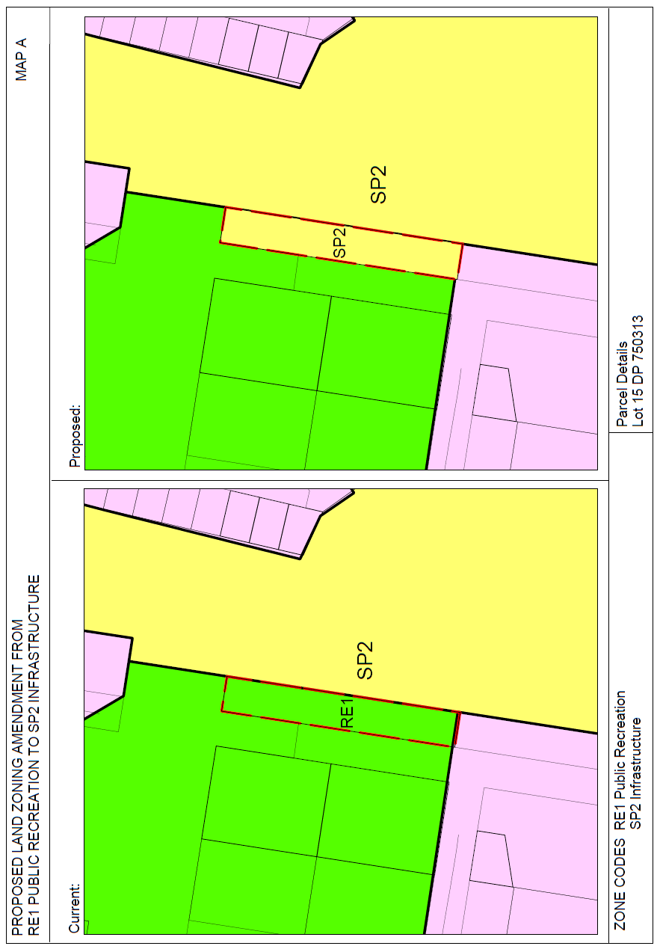

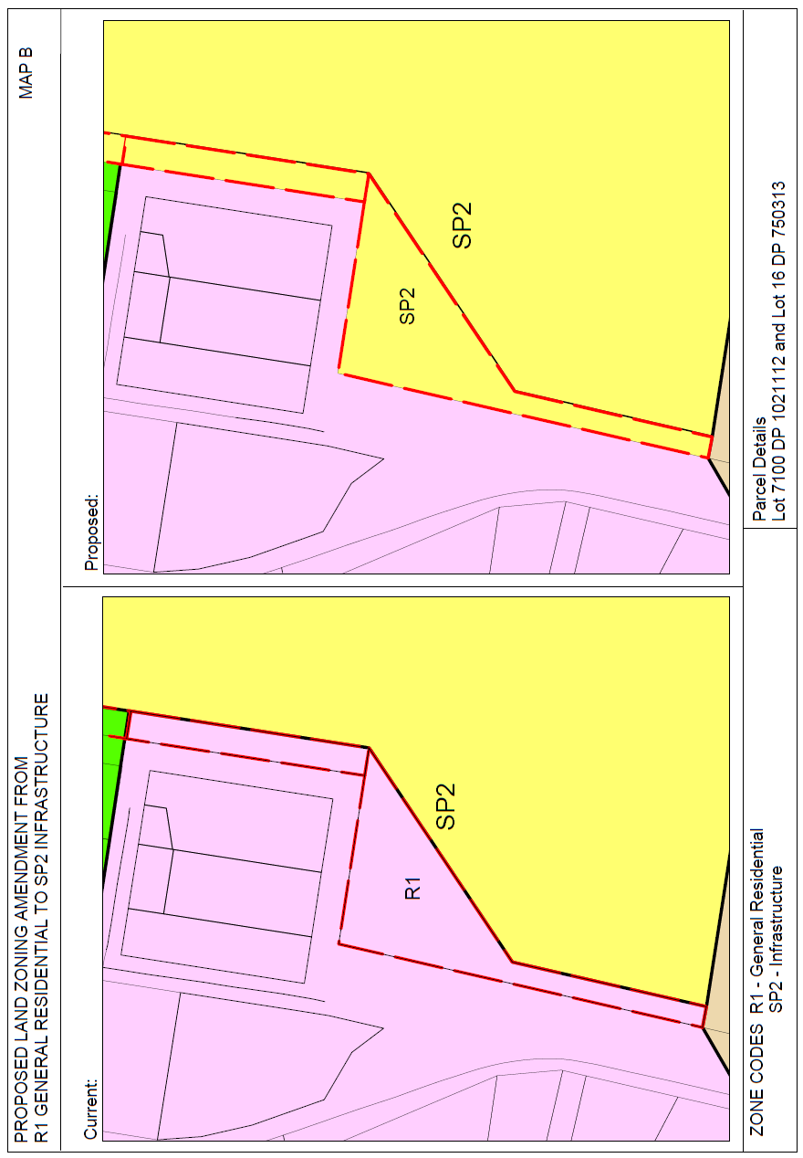

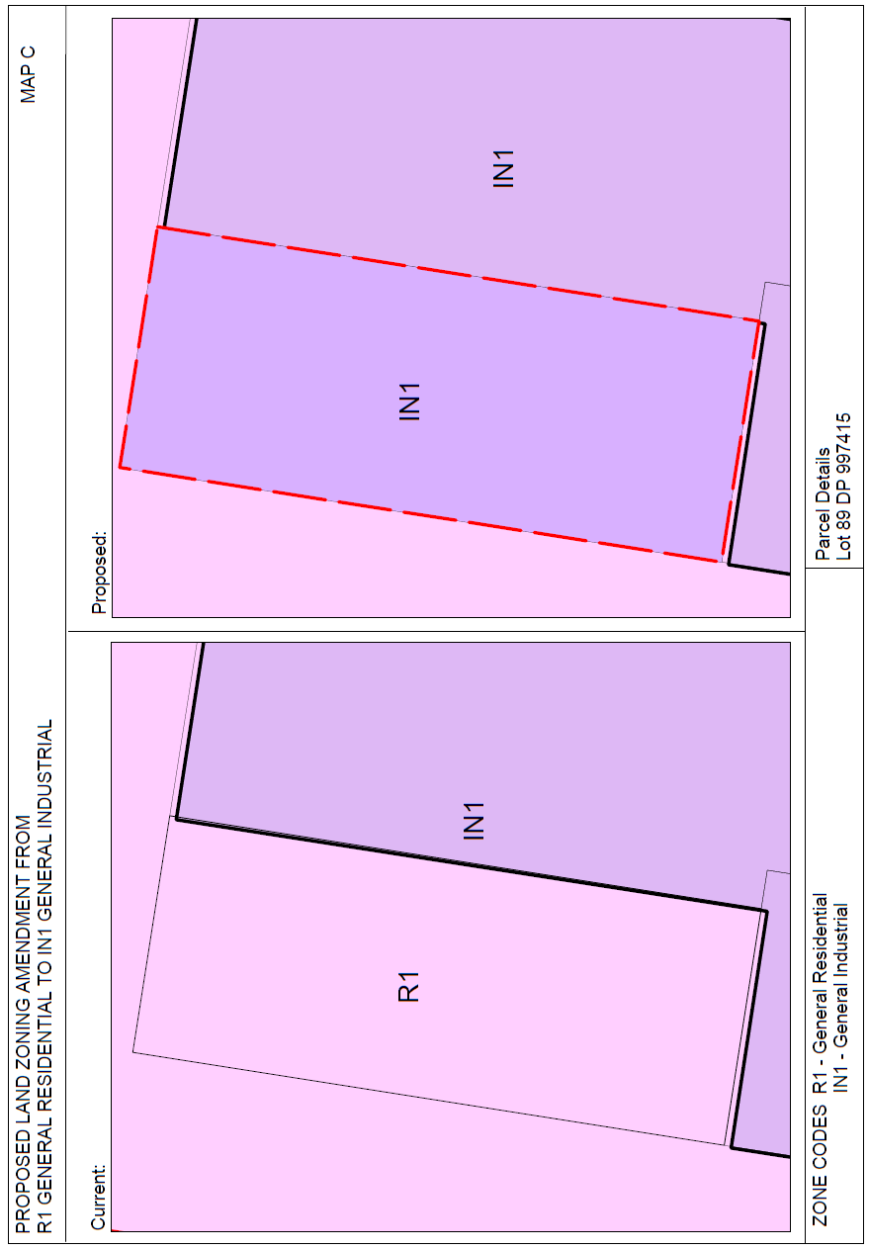

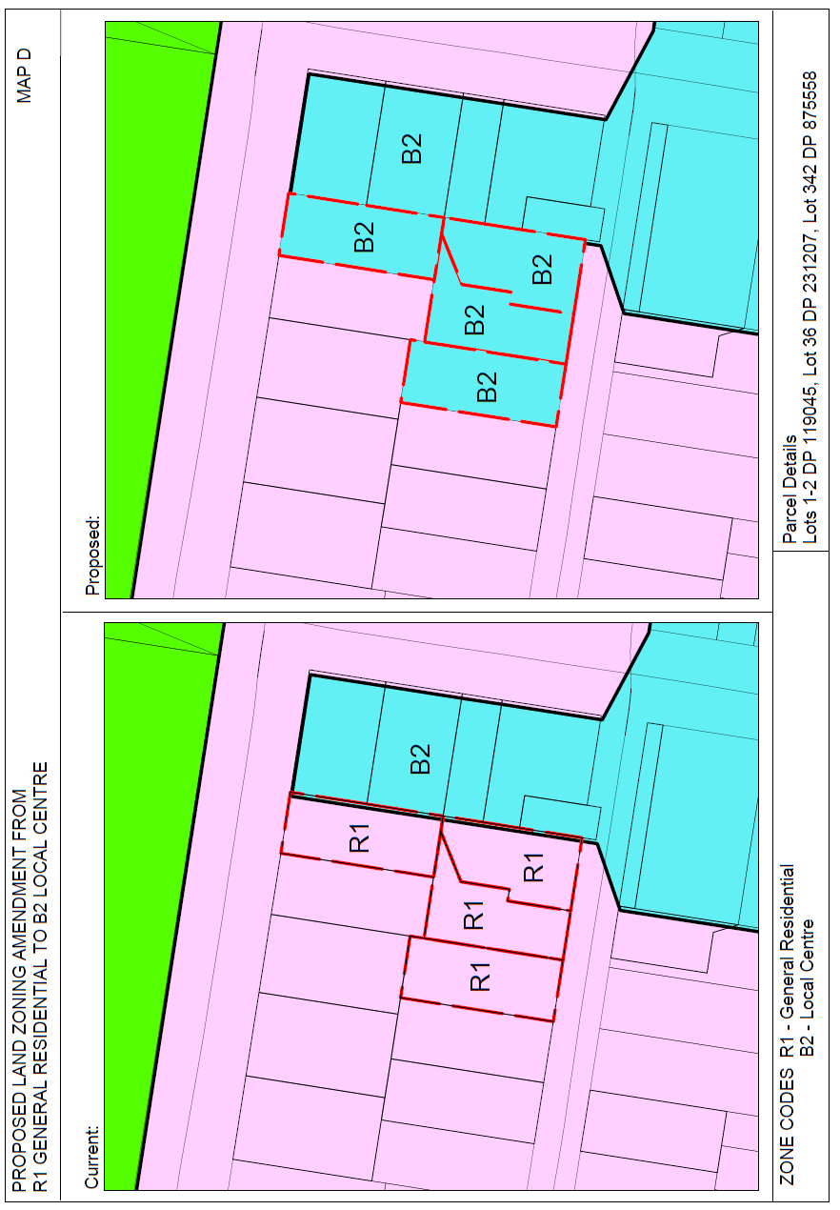

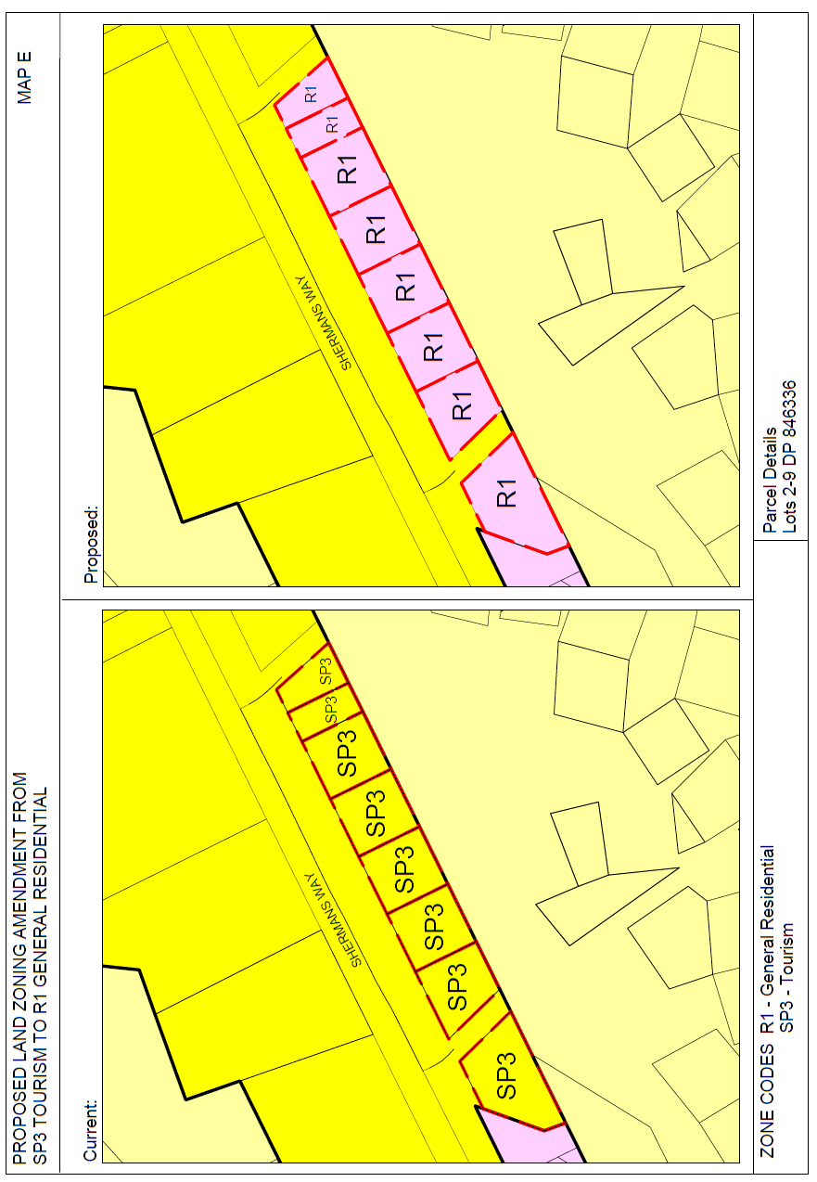

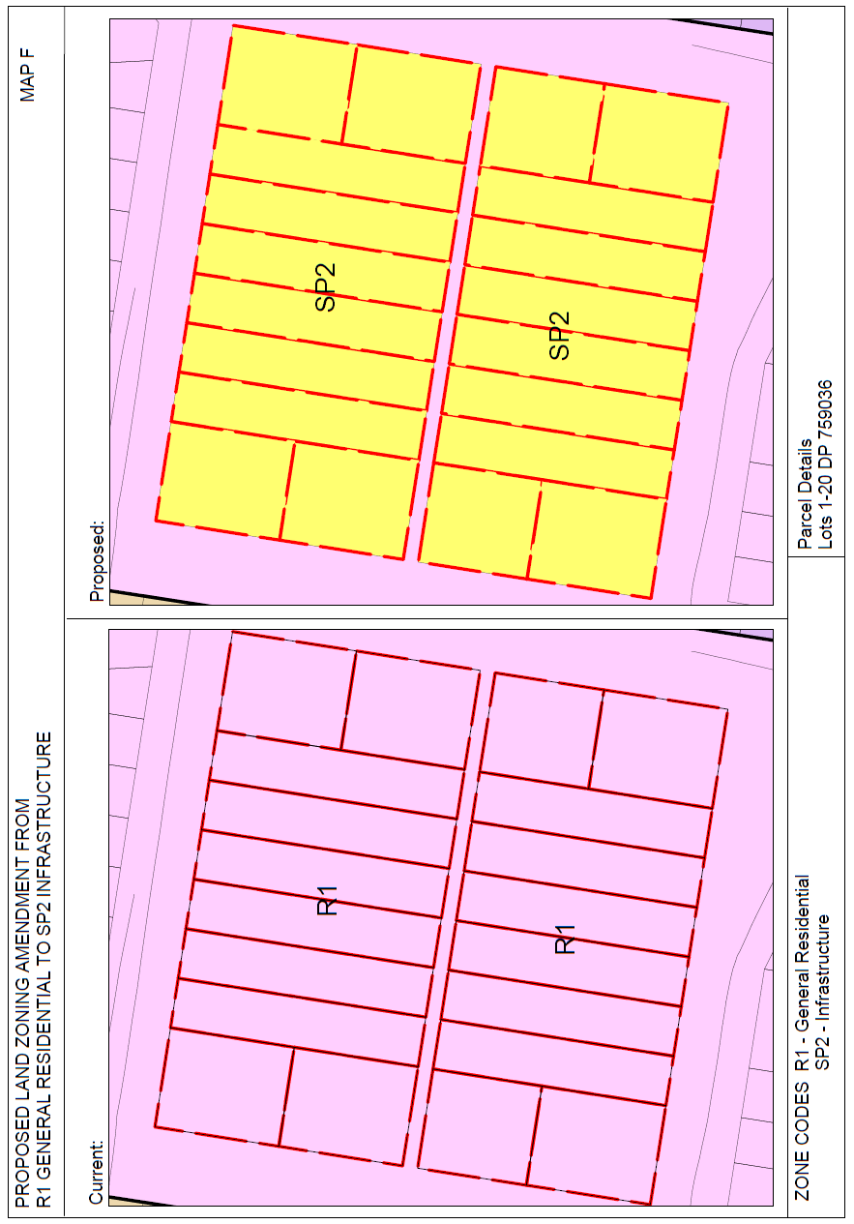

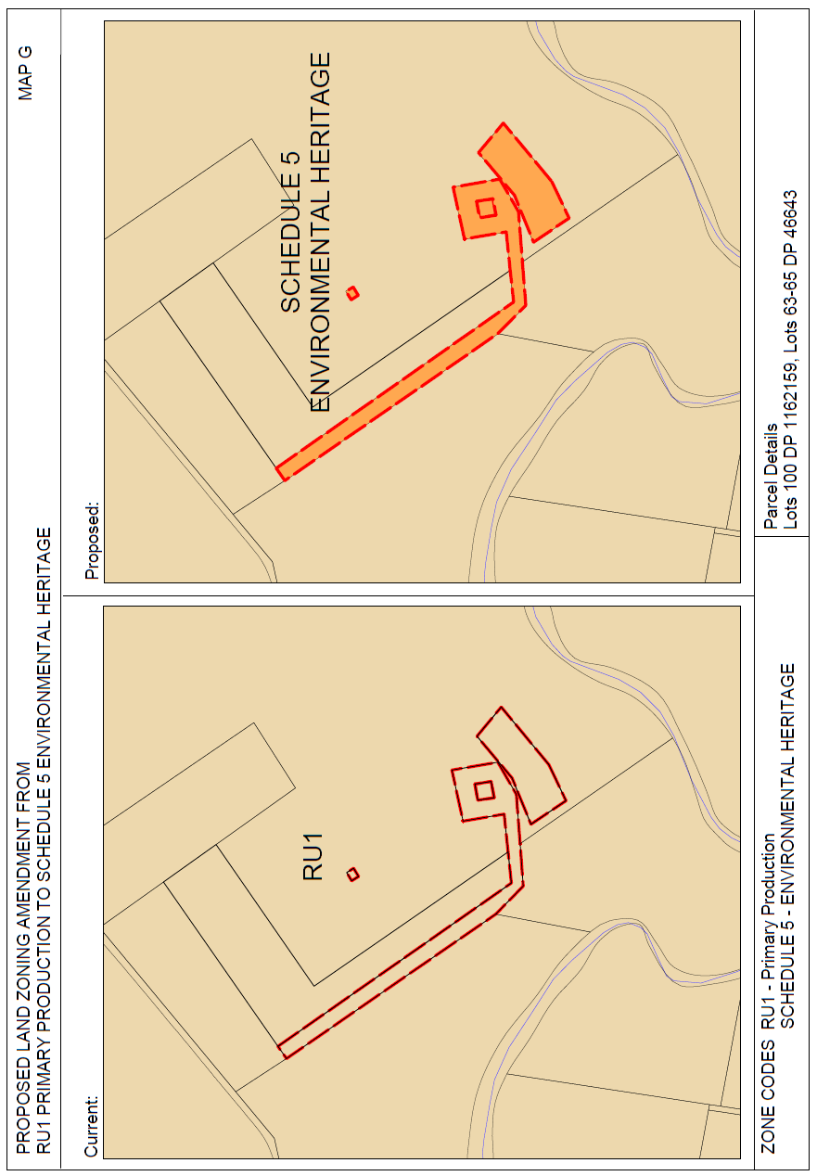

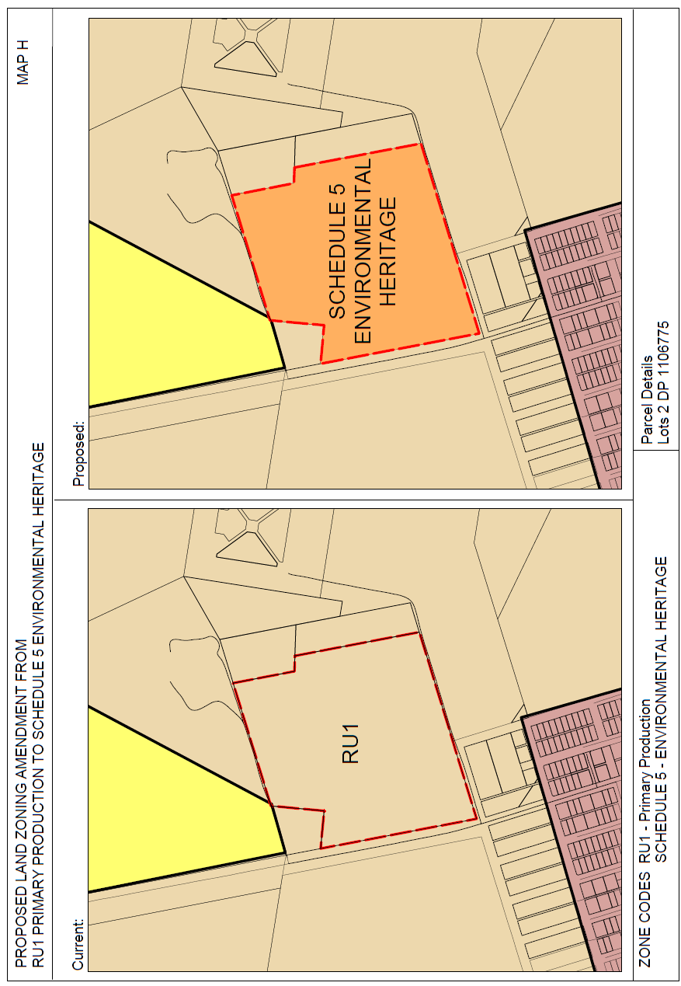

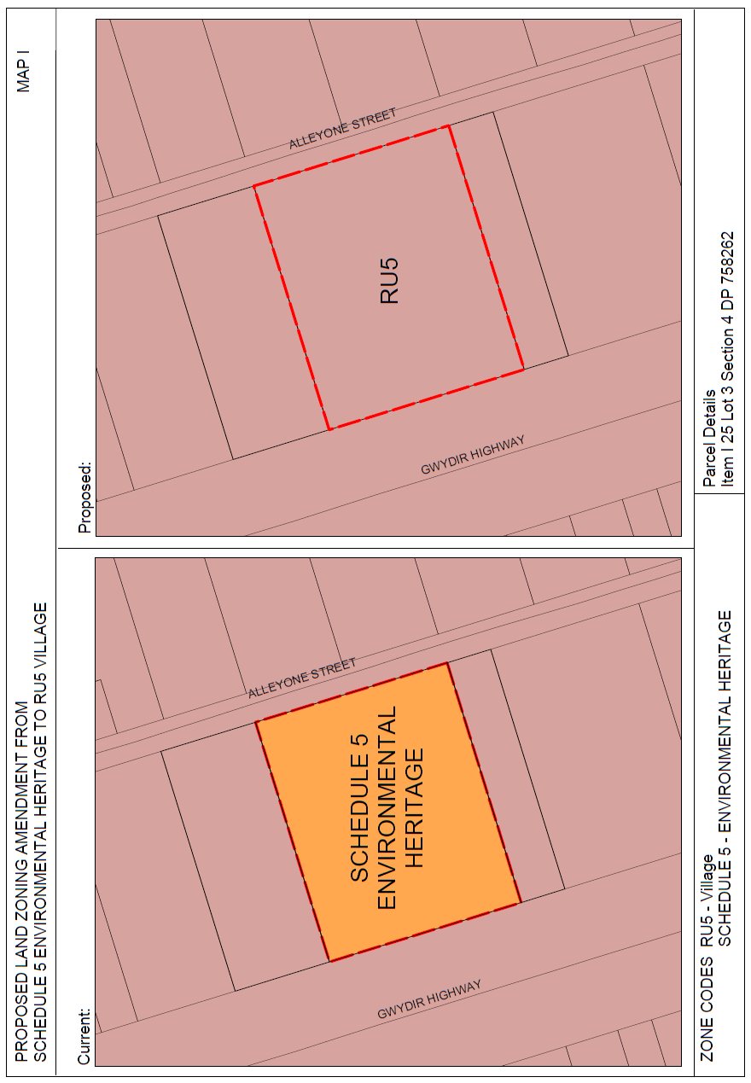

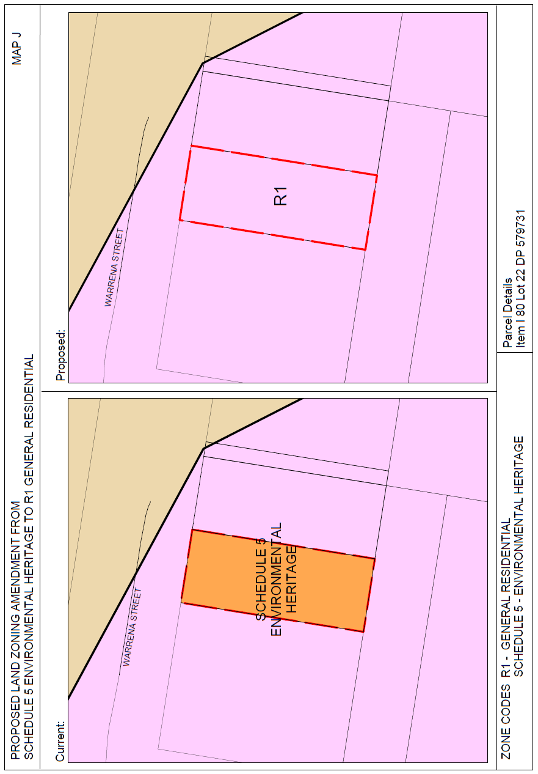

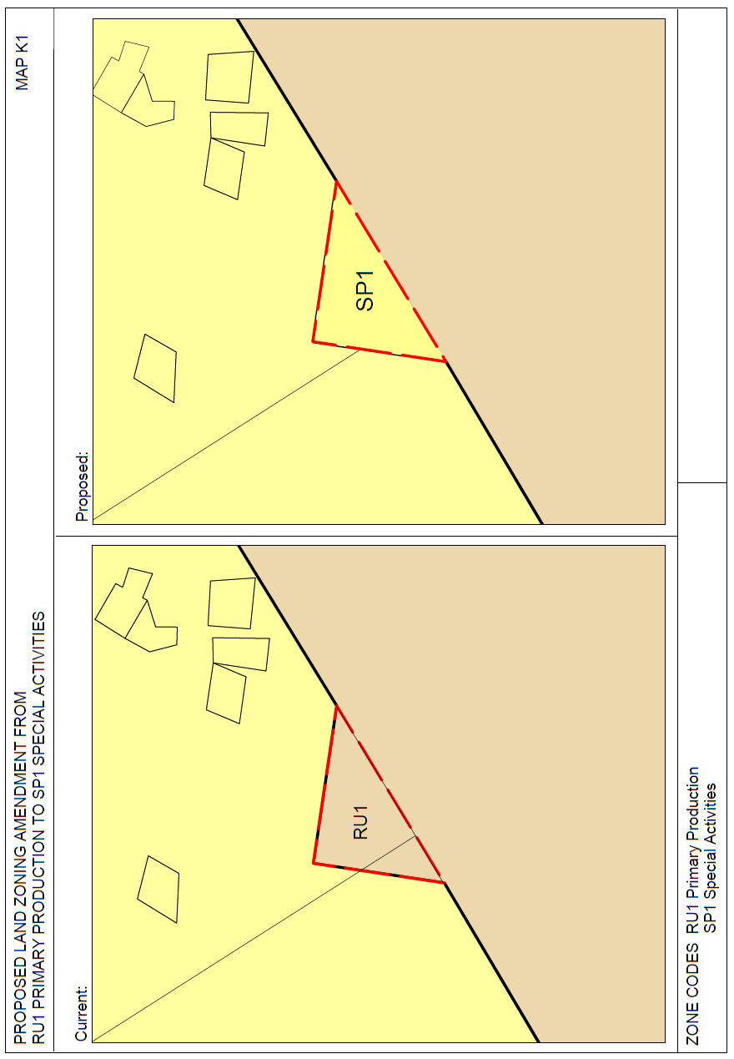

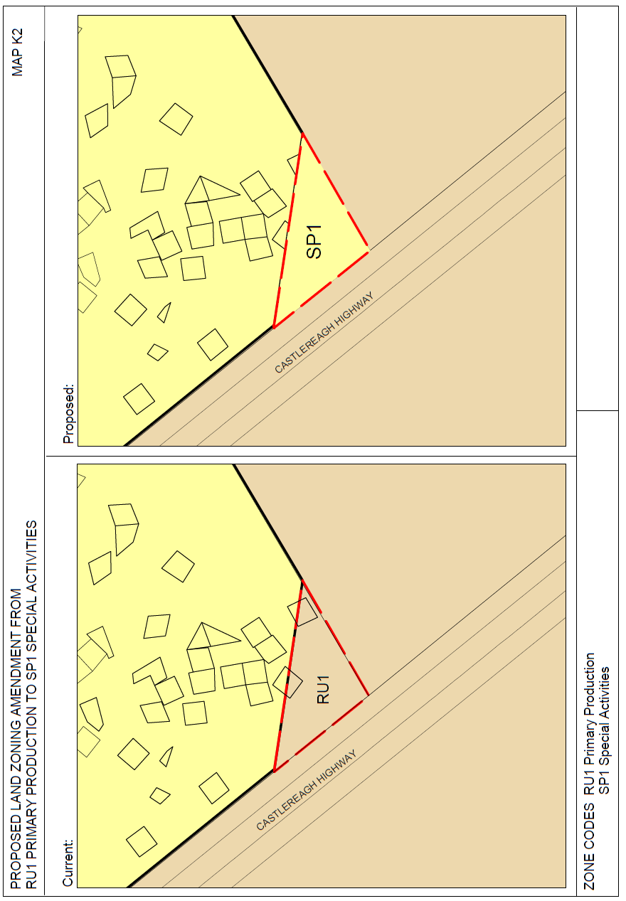

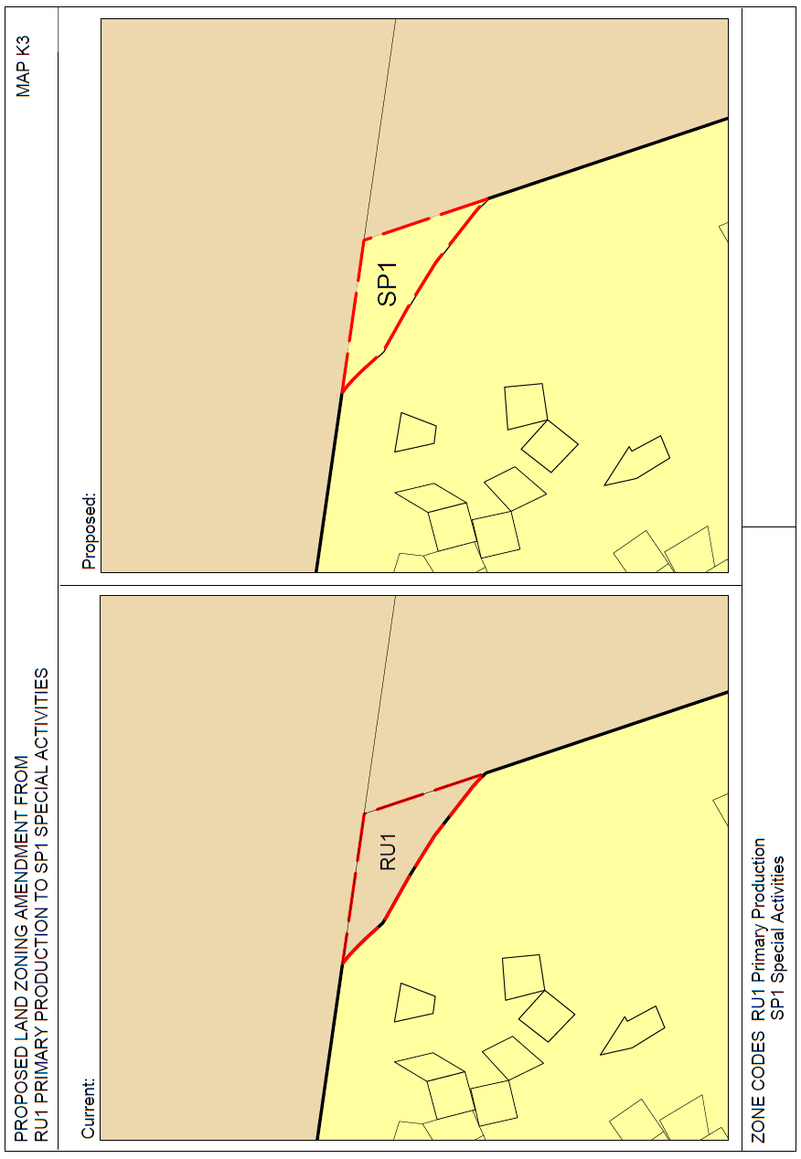

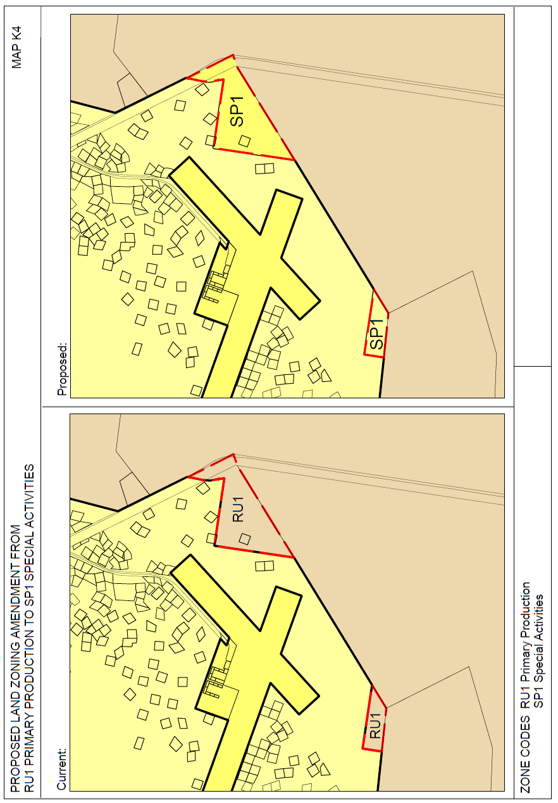

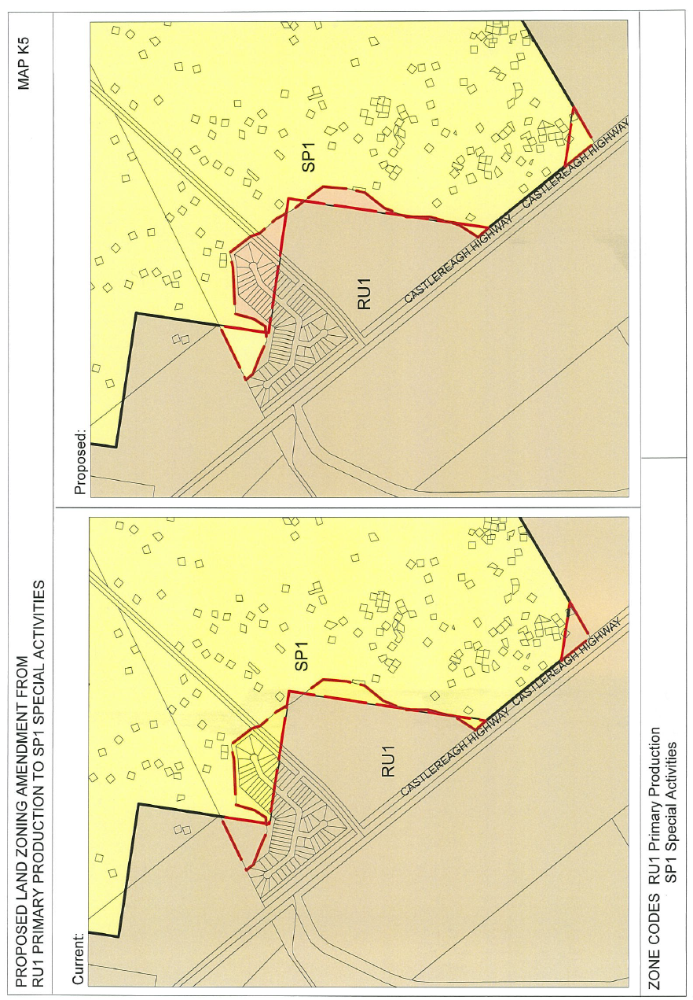

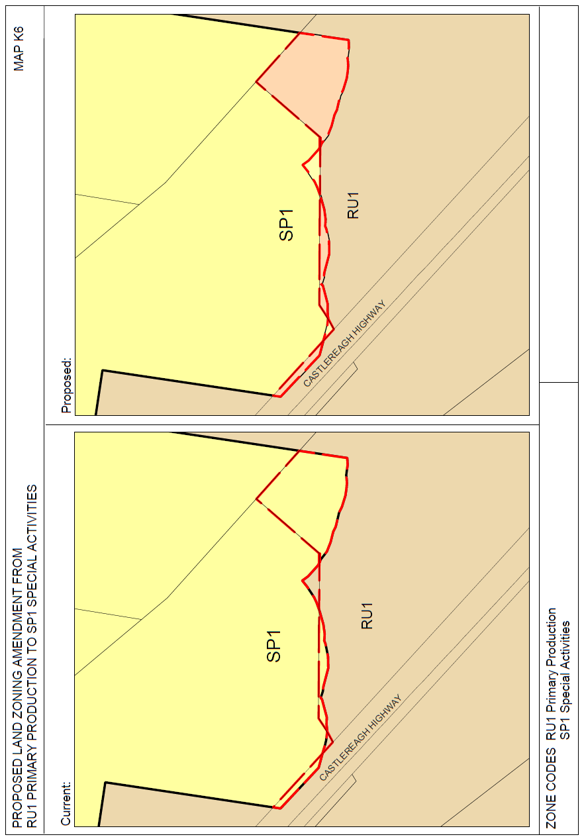

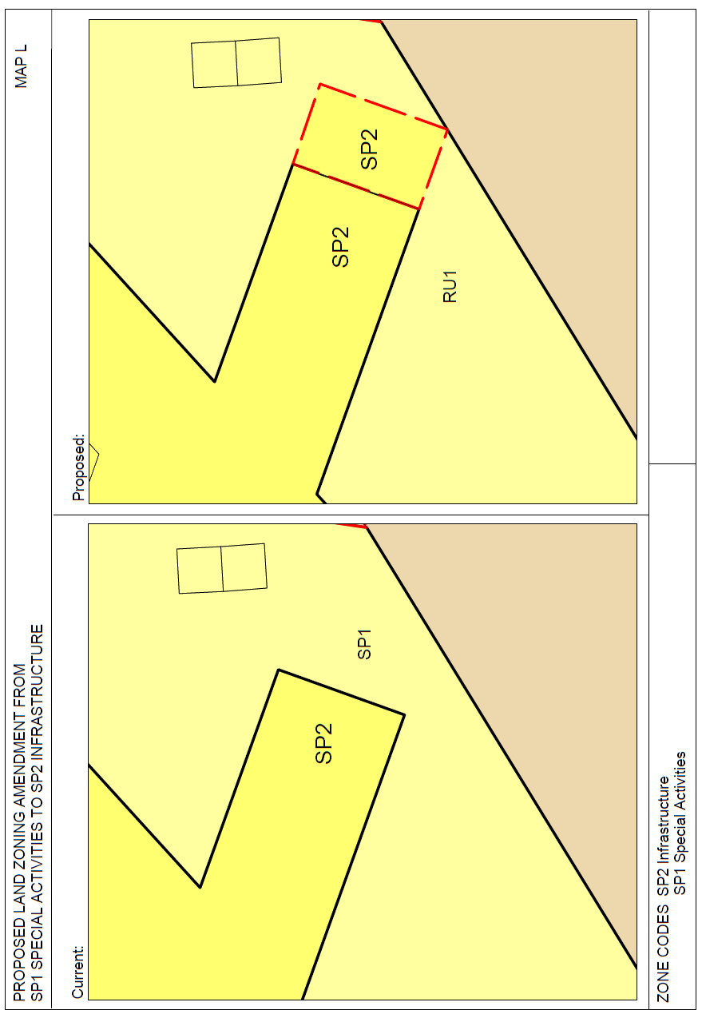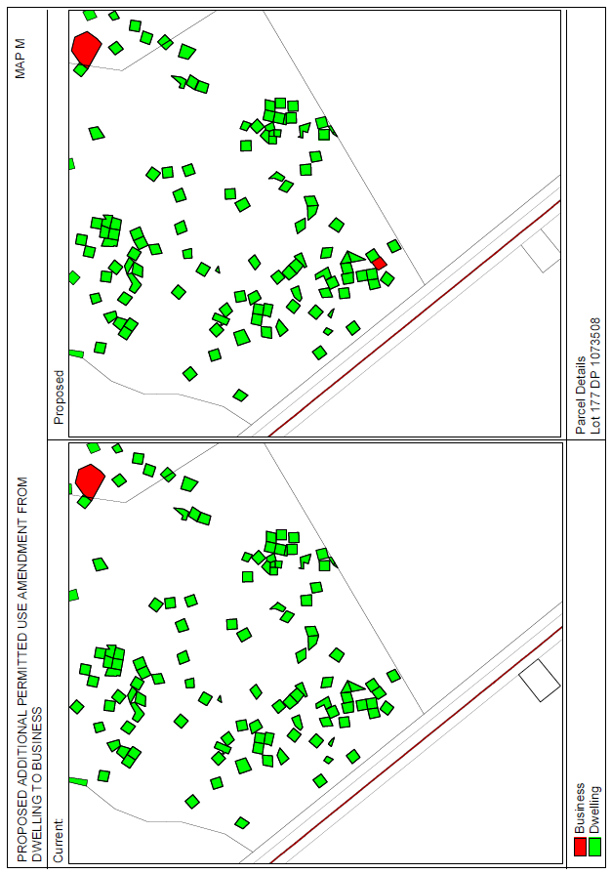

**Attachment B – Consistency with State Environmental Planning Policies**

|  |  |  |
| --- | --- | --- |
| **Relevant State Environmental Planning Policies** | **Consistent** | **Comment** |
| State Environmental Planning Policy No 1—Development Standards | N/A |  |
| State Environmental Planning Policy No 14—Coastal Wetlands | N/A |  |
| State Environmental Planning Policy No 15—Rural Landsharing Communities | N/A |  |
| State Environmental Planning Policy No 19—Bushland in Urban Areas | N/A |  |
| State Environmental Planning Policy No 21—Caravan Parks | N/A |  |
| State Environmental Planning Policy No 26—Littoral Rainforests | N/A |  |
| State Environmental Planning Policy No 29—Western Sydney Recreation Area | N/A |  |
| State Environmental Planning Policy No 30—Intensive Agriculture | N/A |  |
| State Environmental Planning Policy No 32—Urban Consolidation (Redevelopment of Urban Land) | N/A |  |
| State Environmental Planning Policy No 33—Hazardous and Offensive Development | N/A |  |
| State Environmental Planning Policy No 36—Manufactured Home Estates | N/A |  |
| State Environmental Planning Policy No 39—Spit Island Bird Habitat | N/A |  |
| State Environmental Planning Policy No 44—Koala Habitat Protection | N/A | Any assessment under SEPP 44 will come about as the result of an application for new works or Part 5 of the EPAA. |
| State Environmental Planning Policy No 47—Moore Park Showground | N/A |  |
| State Environmental Planning Policy No 50—Canal Estate Development | N/A |  |
| State Environmental Planning Policy No 52—Farm Dams and Other Works in Land and Water Management Plan Areas | N/A |  |
| State Environmental Planning Policy No 55—Remediation of Land | N/A |  |
| State Environmental Planning Policy No 59—Central Western Sydney Regional Open Space and Residential | N/A |  |
| State Environmental Planning Policy No 62—Sustainable Aquaculture | N/A |  |
| State Environmental Planning Policy No 64—Advertising and Signage | N/A |  |
| State Environmental Planning Policy No 65—Design Quality of Residential Apartment Development | N/A |  |
| State Environmental Planning Policy No 70—Affordable Housing (Revised Schemes) | N/A |  |
| State Environmental Planning Policy No 71—Coastal Protection | N/A |  |
| State Environmental Planning Policy (Affordable Rental Housing) 2009 | N/A |  |
| State Environmental Planning Policy (Building Sustainability Index: BASIX) 2004 | N/A |  |
| State Environmental Planning Policy (Exempt and Complying Development Codes) 2008 | N/A |  |
| State Environmental Planning Policy (Housing for Seniors or People with a Disability) 2004 | N/A |  |
| State Environmental Planning Policy (Infrastructure) 2007 | Yes | It is anticipated that future development of some sites proposed to be rezoned will require concurrence from NSW Roads and Maritime Services. |
| State Environmental Planning Policy (Kosciuszko National Park—Alpine Resorts) 2007 | N/A |  |
| State Environmental Planning Policy (Kurnell Peninsula) 1989 | N/A |  |
| State Environmental Planning Policy (Mining, Petroleum Production and Extractive Industries) 2007 | N/A |  |
| State Environmental Planning Policy (Miscellaneous Consent Provisions) 2007 | N/A |  |
| State Environmental Planning Policy (Penrith Lakes Scheme) 1989 | N/A |  |
| State Environmental Planning Policy (Rural Lands) 2008 |  |  |
| State Environmental Planning Policy (SEPP 53 Transitional Provisions) 2011 | N/A |  |
| State Environmental Planning Policy (State and Regional Development) 2011 | N/A |  |
| State Environmental Planning Policy (State Significant Precincts) 2005 | N/A |  |
| State Environmental Planning Policy (Sydney Drinking Water Catchment) 2011 | N/A |  |
| State Environmental Planning Policy (Sydney Region Growth Centres) 2006 | N/A |  |
| State Environmental Planning Policy (Three Ports) 2013 | N/A |  |
| State Environmental Planning Policy (Urban Renewal) 2010 | N/A |  |
| State Environmental Planning Policy (Western Sydney Employment Area) 2009 | N/A |  |
| State Environmental Planning Policy (Western Sydney Parklands) 2009 | N/A |  |

**Attachment C – Consistency with Section 117 Directions**

|  |  |  |
| --- | --- | --- |
| **Direction Title** | **Consistency** | **Comment** |
| 1. Employment and Resources |  |  |
| 1.1 Business and Industrial Zones. | Yes. | Amendments support protection of land in commercial zones. |
| 1.2 Rural Zones. | No. | The small parcels of land which are proposed to be rezoned are of negligible agricultural value, and it is considered appropriate to amend the zone boundaries slightly to align with cadastral boundaries. The changes may reasonably be described as of minor significance. |
| 1.3 Mining, Petroleum Production and Extractive Industries. | N/A. | The proposed APU for an observatory will not restrict the potential to mine extractive materials which are of State or regional significance. |
| 1.4 Oyster Aquaculture. | N/A. |  |
| 1.5 Rural Lands. | N/A |  |
| 2. Environment and Heritage |  |  |
| 2.1 Environment Protection Zones. | Yes. | No environmentally sensitive areas will be affected by the proposal. |
| 2.2 Coastal Protection. | N/A. |  |
| 2.3 Heritage Conservation. | Yes. | Provisions facilitate conservation of appropriate items of heritage significance. |
| 2.4 Recreation Vehicle Areas. | N/A. |  |
| 2.5 Application of E2 and E3 Zones and Environmental Overlays in Far North Coast LEPs. | N/A. |  |
| 3. Housing, Infrastructure and Urban Development | N/A |  |
| 3.1 Residential Zones. | Yes. | Provision is required for future housing needs. Minor significance. |
| 3.2 Caravan Parks and Manufactured Home Estates. | N/A. |  |
| 3.3 Home Occupations. | N/A. |  |
| 3.4 Integrating Land Use and Transport. | N/A. |  |

|  |  |  |
| --- | --- | --- |
| 3.5 Development Near Licensed Aerodromes. | Yes. | Non-residential development. Does not interfere with the OLS. |
| 3.6 Shooting Ranges. | N/A. |  |
| 4. Hazard and Risk |  |  |
| 4.1 Acid Sulfate Soils. | N/A. |  |
| 4.2 Mine Subsidence and Unstable Land. | N/A. |  |
| 4.3 Flood Prone Land. | N/A. |  |
| 4.4 Planning for Bushfire Protection. | N/A. |  |
| 5. Regional Planning |  |  |
| 5.1 Implementation of Regional Strategies. | N/A. |  |
| 5.2 Sydney Drinking Water Catchment. | N/A. |  |
| 5.3 Farmland of State and Regional Significance on the NSW Far North Coast. | N/A. |  |
| 5.4 Commercial and Retail Development along the Pacific Highway, North Coast. | N/A. |  |
| 5.8 Second Sydney Airport: Badgerys Creek. | N/A. |  |
| 5.9 North West Rail Link Corridor Strategy. | N/A. |  |
| 5.10 Implementation of Regional Plans. | N/A. |  |
| 6. Local Plan Making |  |  |
| 6.1 Approval and Referral Requirements. | Yes. | The proposal is substantially consistent with the direction. |
| 6.2 Reserving Land for Public Purposes. | N/A. |  |
| 6.3 Site Specific Provisions. | Yes. | Council does not propose to impose any development standards or requirements in addition to those already contained in that zone. |
| 7. Metropolitan Planning |  |  |
| 7.1 Implementation of A Plan for Growing Sydney. | N/A. |  |
| 7.2 Implementation of Greater Macarthur Land Release Investigation. | N/A. |  |

**Attachment D – Letter from Simon Logan of Walgett Farm and Freight regarding proposed rezoning of Lot 89 DP 997415 from Residential to Industrial**

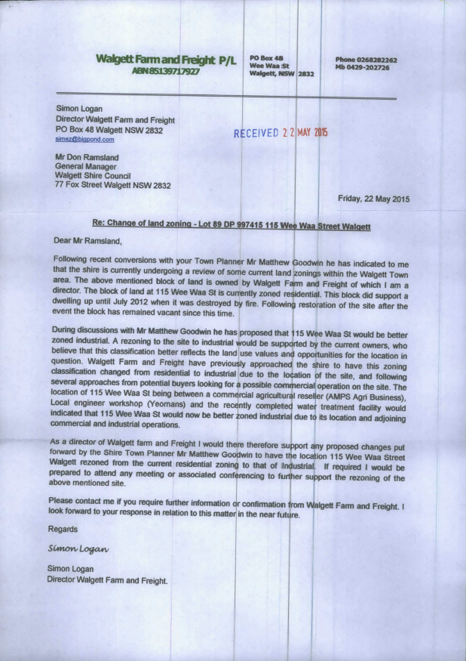

**Attachment E – Letter from Duncan and Duncan Walgett regarding rezoning of Lot 342 DP 875558, Lot 1 DP 1190485, Lot 36 DP 231207 from Residential to Business**

